**Ice Cream Inventory Management**



USE CASE SUMMARY DOCUMENT

Version 1.4

**Project Document Revision History**

|  |  |  |  |
| --- | --- | --- | --- |
| **VersionNumber** | **Date** | **Revision Author** | **Description of Revision** |
| 1.0 | 3/9/2016 | Spencer Vierk | Creation of document |
| 1.1 | 3/10/2016 | Brandon Manni/Spencer Vierk | Modifying use case list. |
| 1.2 | 3/14/2016 | Spencer Vierk | Updating document content |
| 1.3 | 3/16/2016 | Spencer Vierk | Updating document content |
| 1.4 | 3/17/2016 | Spencer Vierk | Fixed Table of Contents, included Use Case Diagram, fixed formatting issues |

|  |
| --- |
| **Table of Contents** |

# 

1. Introduction 4
2. Project/Application Actors 4
3. Use Case List 5
4. Use Case Diagram 5
5. Use Case Summary 6-7
6. Use Case Summary Review and Signoff 8

# 

# **Introduction**

The purpose of this project is to build an Ice Cream Inventory Management system that manages the inventory of the company’s ice cream trucks and the company warehouse as a whole. The program will be able to display the ice cream inventory at any given moment, and will also update the inventory at the end of each day based on the individual truck inventories. It will also be calculating sales per vehicle on a day to day basis, as well as historical sales data. In addition, the program will also be able to assign ice cream trucks to certain routes and display the trucks on a given route at a certain point in time.

# **Project/Application Actors**

|  |  |
| --- | --- |
| Actor Name | Description |
| Customer | Interacts with Driver, purchases ice cream from driver as well as gives Driver information |
| Driver | Interacts with Customer and User, sells ice cream to Customer as well as gives User information about sales, inventory and ice cream requests |
| User | Interacts with System and Driver, receives information from Driver, inputs data into System as well as controls the interface. |
| System | User controls the System. The System handles data in the database as well as processes requests from the User including displaying, updating and performing calculations on the data held in both the database and in within the System.. |
| Message Receiver | Receives text messages to a mobile phone which are sent from the System. Generally a Manager or someone who is interested in making sure everything is going smoothly. |

# **Use Case List**

1. Customer Request
2. Product and Driver Sales Tracking
3. Text Message Notifications
4. Financial Accounting Service
5. Automatic Ordering
6. Display Inventory, Trucks, Routes, Sales Per Truck and Route
7. Update Ice Cream Inventory/Price and Truck Inventory
8. Assign Truck to Route
9. Data File Processing

# **Use Case Diagram(s)**

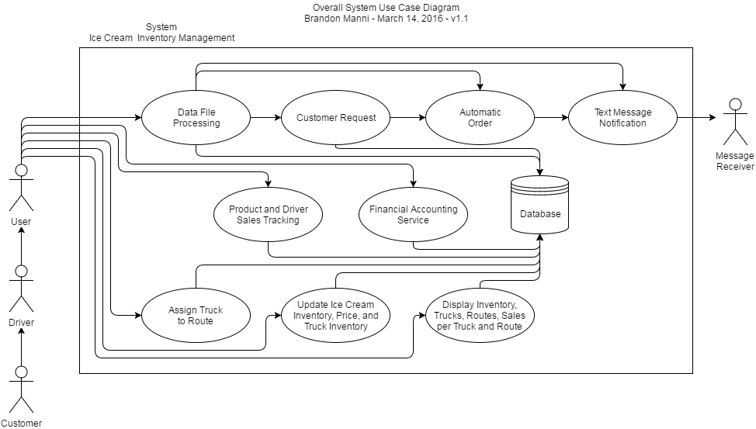

# **Use Case Summary**

|  |  |  |  |
| --- | --- | --- | --- |
| (Diagram #) - Name | Introduction | Main Actors | Secondary Actors |
| 1 - Customer Request | The Customer Request allows customers to request new products. Those requests will be recorded and once enough requests for a product are received, it will be added to the automatic order. The purpose is for the business to maximize profits. New requested products will be ordered. | Customer | Driver  User  System |
| 2 - Product and Driver Tracking | The Product and Driver Sales Tracking is a way to view which products have been selling the most and which drivers have been performing the best overall and over a time period. The purpose is to be able to analyze the data and make decisions that can benefit the company financially. If a product is selling more than others, the business can make the decision to buy more of that product over others that might not be selling as well. | User | System |
| 3 - Text Message Notification | The Text Message Notification use case allows text messages to be sent to a specified phone number. A message is sent when a certain action happens. Any individual notifications can be turned on/off. The purpose of this use case is for someone outside of work receive notifications about things happening in the software, for example, the owner of the company can receive notifications while away from work. | User | System  Message Receiver |
| 4 - Financial Accounting Service | The Financial Accounting Service allows the user to retrieve revenue and profits overall and over a specific time period. The purpose is for the business to be able to see current financial status of the company. If the company is doing well, they might make the decision to expand or buy more trucks. | User | System |
| 5 - Automatic Ordering | The Automatic Order use case allows the user to quickly generate an order to fill up inventory. The system will check the current inventory and count up what products are needed and how much of each product is needed. | User | System |
| 6 - Display Ice Cream Inventory, Trucks, Routes, and Sales Per Truck and Route. | The Display Data use case allows the user to display the data in the system. The purpose is to be able to see current inventory, costs, products, and all other data in the database. | User | System |
| 7 - Update Ice Cream Inventory/Price and Truck Inventory | The Update Inventory, Price, and Truck Inventory use case allows the user to edit the data being stored in the database. Example, if the user submitted a file with the wrong data, inventory was counted wrong. The purpose is to allow the user to fix mistakes they may have entered. | User | System |
| 8 - Assign Truck to Route | The Assign Truck to Route use case allows trucks to be assigned to new routes. The purpose is to allow for flexibility. Different trucks can take different routes depending on the circumstances. For example, maybe a driver can’t come in for a day, so a different truck can pick up the unoccupied route. | User | System |
| 9 - Data File Processing | The Data File Processing use case allows the user to input multiple data files into a directory which will then be pulled into the program. The purpose is to allow a fast way for the user to input data into the program. The system will check the files before saving them to the database. | User | System |

# **Use Case Summary Review and Signoff**

|  |  |  |  |  |
| --- | --- | --- | --- | --- |
| Review and Signoff of the Use Case Summary | | | | |
| Name | Project Team Role | Signature | Date | |
| Brandon Manni | Design/Functionality | Brandon Manni | 3/16/16 | |
| Haris Khan | Modeling | Haris Khan | 3/17/16 | |
| Spencer Vierk | Programmer | Spencer Vierk | 3/16/16 | |
| Anthony Robinson | Testing | Anthony Robinson | 3/16/16 | |
| Jacob Tufts | Team Lead |  |  | |
| Harmandeep Kaur | Project Manager | Harmandeep Kaur | 3/17/16 | |